Lecture 9.

Immune response, its types (cellular and humoral) and mechanisms. Cooperation of immuncompetent cells in the immune response. Immune response. Antibody formation, immunoglobulins and their classes. Immune phagocytosis, hypersensitivity reactions, immunological memory, immunological tolerance, antibody-dependent and independent. Characteristics of the immune response depending on the pathogen

The purpose of the lecture: To teach students the immune response, its types (cellular and humoral) and mechanisms, cooperation of immunocompetent cells in the immune response, information about the immune response. Explain antibodies (immunoglobulins), their nature, structure, basic classes, types and properties. To explain the characteristics of immune phagocytosis, hypersensitivity reactions, immunological memory, immunological tolerance, antibody-dependent and non-dependent cytotoxicity, as well as the characteristics of the immune response depending on the pathogen.

Lecture plan:
1. Immune response, its mechanism, types and forms:
- Cellular immune response and its mechanism. Transmission of information from antigen-presenting cells to T1-helpers and cytotoxic T-lymphocytes, the formation of T-killers, their interaction with target cells. Antibody-dependent and cell-independent cytotoxicity.
- Humoral immune response and its mechanism. Transfer of information from antigen-presenting cells to T2-helpers and B-lymphocytes, formation of plasma cells, synthesis of specific antibodies.
2. Antibodies (immunoglobulins), nature and molecular structure. Classes of immunoglobulins,
structures and basic functions; types of antibodies (receptor, normal, monoclonal, complete and incomplete antibodies) and their characteristics. Dynamics of antibody formation.
3. Immune phagocytosis, hypersensitivity reactions, immunological memory, immunological tolerance, antibody-dependent and independent cytotoxicity.
4. Characteristics of the immune response depending on the pathogen

Human beings have four basic lines of protection against inappropriate microbial infection:
1. Natural barriers such as skin, mucus, ciliated epithelium, gastric acid, and bile restrict entry of the agent.
2. Competition with normal flora.
3. Innate antigen-nonspecific immune defenses such as fever, antimicrobial peptides, interferon, complement, neutrophils, macrophages, dendritic cells (DCs), innate lymphoid cells (including natural killer [NK] cells), and innate T cells (mucosal-associated invariant
T cell [MAIT], NK T cell [NKT], T cells) and B-1 B cells provide continuous or rapid local responses at body surfaces and at the infection site to restrict the growth and spread of the agent.
4. Adaptive antigen-specific immune responses such as antibody and T cells reinforce the innate protections; specifically they target, attack, and eliminate the invaders that succeed in passing the first two defenses, as well as the infected cells; and they remember the pathogen for future challenges.
Antimicrobial Actions of Antibodies
Opsonize: promote ingestion and killing by phagocytic cells (IgG)
Neutralize: block attachment of bacteria bacteria, toxins, and viruses
Agglutinate bacteria: aids in clearing
Render motile organisms nonmotile
Combine with antigens on the microbial surface and activate the complement cascade, thus inducing an inflammatory response, bringing fresh phagocytes and serum antibodies into the site Combine with antigens on the microbial surface, activate the complement cascade, and anchor the membrane attack complex

Comparative structures of the immunoglobulin (Ig) classes and subclasses in humans. IgA and IgM are held together in multimers by the J chain. IgA can acquire the secretory component for the traversal of epithelial cells.

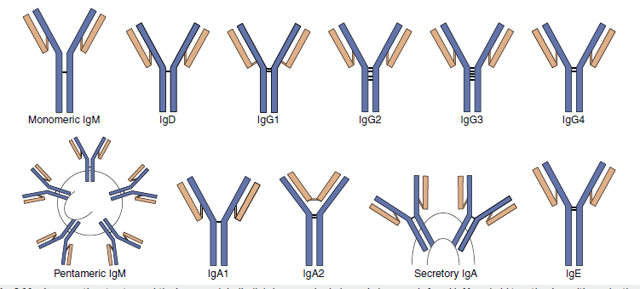

Properties and Functions of Immunoglobulins
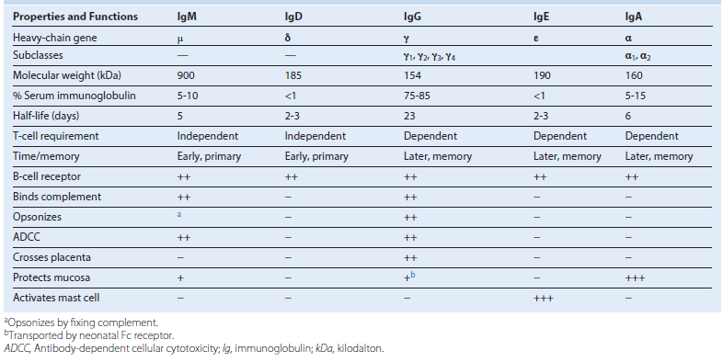

Fc Interactions with Immune Components
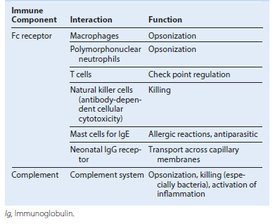

Proteolytic digestion of immunoglobulin (Ig)G. Pepsin treatment produces a dimeric F(ab′)2 fragment. Papain treatment produces monovalent Fab fragments and an Fc fragment. The F(ab′)2 and the Fab fragments bind antigen but lack a functional Fc region. The heavy chain is depicted in blue; the light chain in orange. mol. wt., Molecular weight.
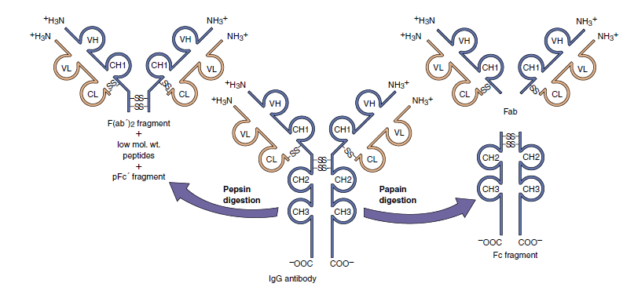

Immunoglobulin class switching. T-cell help induces differentiation of the B cell and promotes genetic recombination, somatic mutation, and immunoglobulin class switching. Switch regions in front of the constant-region genes (including IgG and IgA subclasses) allow attachment of the preformed VDJ region to other heavy-chain constant- region genes, genetically removing the μ, _, and other intervening genes. This produces an immunoglobulin gene with the same VDJ region (except for somatic mutation) and the desired antigen specificity but with different Fc-determined functions.
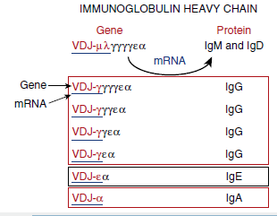

T-cell help determines the nature of the immune response. Receptor-ligand interactions between T cells and B cells and cytokines associated with TH1 or TH2 determine the subsequent response. TH1 responses are initiated by interleukin (IL)-12 and delivered by interferon-_ (IFN-_) and IL-2 to promote cell-mediated and immunoglobulin (Ig)G production (solid blue lines) and inhibit TH2 responses (dotted blue lines). IL-4 and IL-5 from TH2 cells promote humoral responses (solid red lines), and IL-4 and IL-10 inhibit TH1 responses (dotted red lines). Mucosal epithelium promotes secretory IgA production. Colored boxes denote end results. ↑, Increase; ↓, decrease; ADCC, antibody-dependent cellular cytotoxicity; APC, antigen-presenting cell; CTL, cytotoxic T lymphocyte; DCs, dendritic cells; DTH, delayed type hypersensitivity; GM-CSF, granulocyte-macrophage colony-stimulating factor; TNF, tumor necrosis factor.
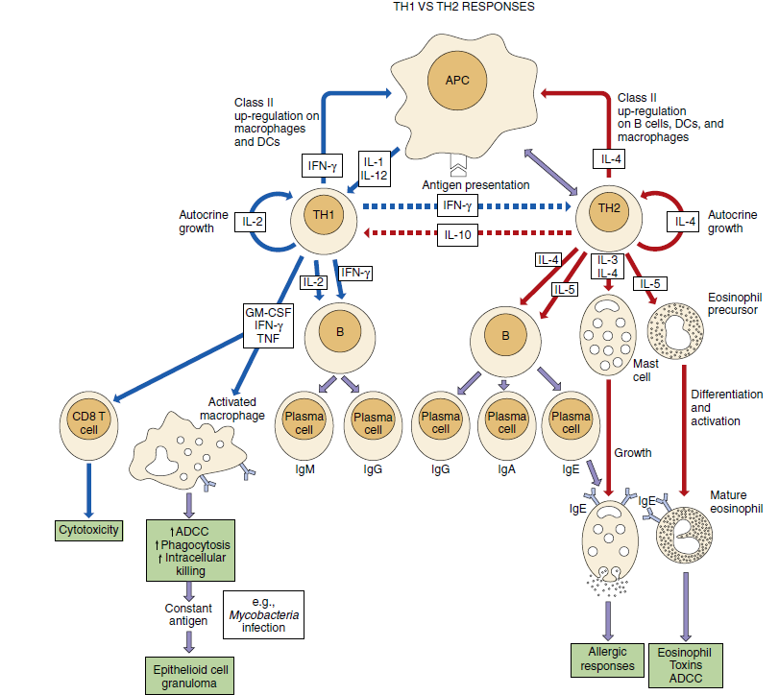

Somatic mutation and clonal selection in the germinal centers of lymph nodes. B cells activated by CD4 T cells enter the dark zone of the germinal center, proliferate, and undergo mutation of the immunoglobulin genes and isotope switching. The mutations trigger apoptosis. The B cells proceed to the light zone of the germinal center in which follicular dendritic cells (FDC) act like bulletin boards to display multiple units of the antigen to surface antibody on B cells. B cells with surface immunoglobulin that bind tightly to antigen and present peptides recognized by follicular helper cells (Tfh) receive a survival signal from the Tfh while the other B cells die by apoptosis. The surviving B cells may recycle through the dark zone to repeat the cycle or receive signals for differentiation into memory cells or plasma cells and leave the lymph node. MHC, Major histocompatibility complex; TCR, T-cell receptor.
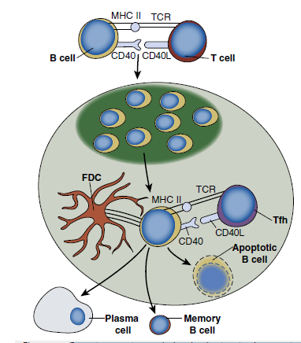

Time course of immune responses. The primary response occurs after a lag period. The immunoglobulin (Ig)M response is the earliest response. The secondary immune response (anamnestic response) progresses faster, reaches a higher titer, lasts longer, and consists predominantly of IgG.
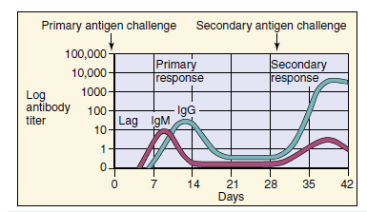

Importance of Antimicrobial Defenses for Infectious Agents
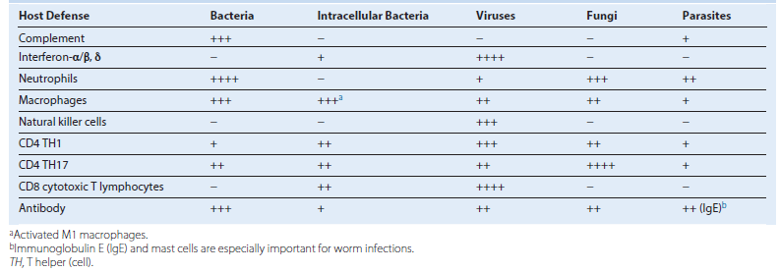

Antibacterial responses to a splinter. The time course proceeds from local (left) to lymph node (right) and then returns as indicated at the top of the figure. First, innate antigen-nonspecific responses attract and promote polymorphonuclear neutrophil (PMN) and macrophage (M_) responses. Epithelial cells and other cells produce antimicrobial peptides (not shown). Dendritic cells (DCs) mature taking antigen to the lymph node to activate early immune responses (TH17, TH1, IgM, and IgG). TH1 and TH17 cells mobilize to the site of infection to provide cytokine help. Later, when antigen reaches the lymph node through lymphatics, TH2 systemic antibody responses are developed. APC, Antigen-presenting cell; CTL, cytotoxic T lymphocyte; Ig, immunoglobulin; IFN-γ, interferon-β; IL, interleukin; TGF-β, transforming growth factor-α; TH, T helper (cell); TNF-α, tumor necrosis factor.
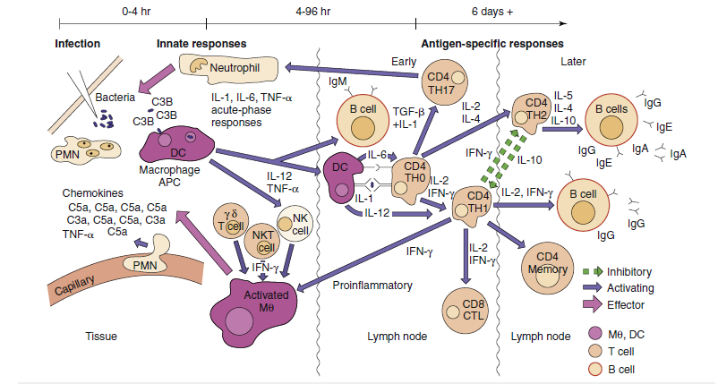

Summary of Antibacterial Responses
Antimicrobial Peptides and Proteins
Defensins and other peptides disrupt membranes
Transferrin, lactoferrin, and other proteins sequester iron and other essential ions
Complement
Production of chemotactic and anaphylatoxin proteins (C3a, C5a)
Opsonization of bacteria (C3b)
Promotion of killing of gram-negative bacteria
Activation of B cells (C3d)
Neutrophils
Important antibacterial phagocytic cells
Killing by oxygen-dependent and oxygen-independent mechanisms
Activated Macrophages (M1)
Important antibacterial phagocytic cells
Killing by oxygen-dependent and oxygen-independent mechanisms
Production of TNF-α, IL-1, IL-6, IL-23, IL-12
Activation of acute-phase and inflammatory responses
Presentation of antigen to CD4 T cell
Dendritic Cells
Production of acute phase cytokines (TNF-α, IL-6, IL-1); IL-23; IL-12; IFN-α
Presentation of antigen to CD4 and CD8 T cells
Initiation of immune responses in naive T cells
T Cells
γ/δ T-cell and MAIT cell response to bacterial metabolites
NKT cell response to CD1 presentation of mycobacterial glycolipids
TH17 CD4 response activates neutrophils and epithelial cells
TH1 CD4 responses important for bacterial, especially intracellular, infections
TH2 CD4 response important for antibody protections
Antibody
Binding to surface structures of bacteria (fimbriae, lipoteichoic acid, capsule)
Blocking of attachment
Opsonization of bacteria for phagocytosis
Promotion of complement action
Promotion of clearance of bacteria
Neutralization of toxins and toxic enzymes
IFN-Interferon; IL-interleukin; MAIT-mucosal-associated invariant T cell; NKT-natural killer T (cell); TH- T helper (cell); TNF- tumor necrosis factor.

Initiation and expansion of specific immune responses. Immature dendritic cells (iDCs) at the site of infection acquire microbial debris and become activated by Toll-like receptors (TLRs) and other pathogen pattern receptors binding their ligands. DCs produce cytokines, mature, and move to the lymph node. DCs present peptide antigen to naive T cells to initiate the antigen-specific and cytokine-directed response. During a secondary or memory response, B cells, macrophages, and DCs can present antigen to initiate the response. IFN-γ_ Interferon; IL- interleukin; M- macrophage; TH, T helper (cell).

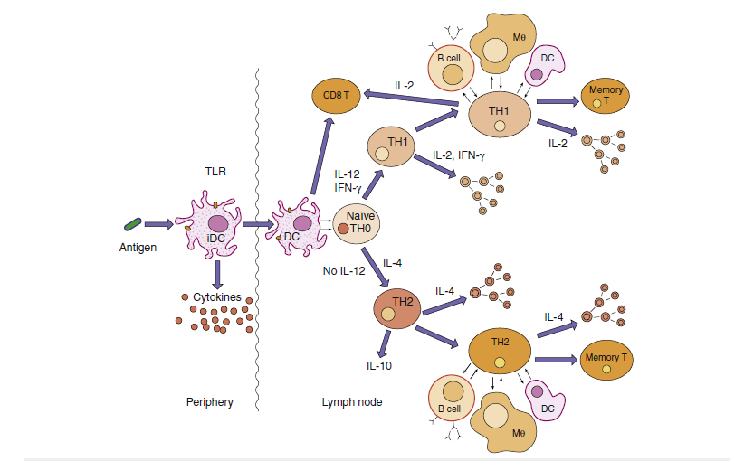

Antiviral responses. The time course proceeds from local (left) to lymph node (right) and then returns to the infected site. The response to a virus (e.g., influenza virus) initiates with type 1 interferon production and action and natural killer (NK) cells. Dendritic cell (DC) initiation of CD4 and CD8 T cells is followed by activation of antigen-specific immunity similar to the antibacterial response, except that CD8 cytotoxic T lymphocytes (CTLs) are important antiviral responses. IFN, interferon; Ig, immunoglobulin; IL, interleukin; M_, macrophage; TH, T helper (cell); TNF, tumor necrosis factor.
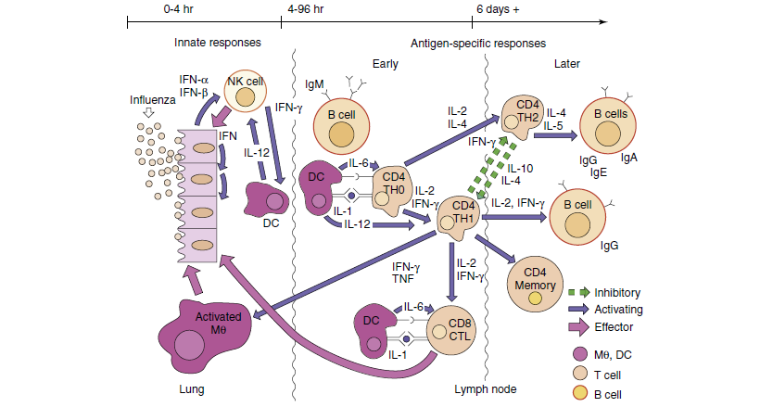

Basic Properties of Human Interferons
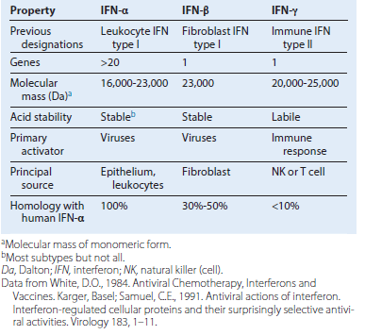

Summary of Antiviral Responses
Antiviral state blocks viral replication on infection
Activates NK cells and systemic antiviral responses
NK Cells
Activated by IFN and IL-12
Produce IFN, which activates macrophages and DCs
Target and kill virus-infected cells (especially enveloped viruses)
Macrophages and DCs
Macrophages filter viral particles from blood
Macrophages inactivate opsonized virus particles
Immature and plasmacytoid DCs produce IFN and other cytokines
DCs initiate and determine the nature of the CD4 and CD8 T-cell response
DCs and macrophages present antigen to CD4 and CD8 T cells
T Cells
Essential for controlling enveloped and noncytolytic viral infections
Recognize viral peptides presented by MHC molecules on cell surfaces
Antigenic viral peptides (linear epitopes) can come from any viral protein (e.g., glycoproteins, nucleoproteins)
CD4 T cells promote and regulate antiviral responses
CD8 cytotoxic T cells respond to viral peptide: class I MHC protein complexes on the infected cell surface
Antibody
Neutralizes extracellular virus:
It blocks viral attachment proteins (e.g., glycoproteins, capsid proteins)
It destabilizes viral structure
Opsonizes virus for phagocytosis
Promotes killing of target cell by the complement cascade and antibody-dependent cellular cytotoxicity
Resolves lytic viral infections
Blocks viremic spread to target tissue
IgM is an indicator of recent or current infection
IgG is a more effective antiviral than IgM
Secretory IgA is important for protecting mucosal surfaces
Resolution requires elimination of free virus (antibody) and the virus-producing cell (viral or immune cell–mediated lysis)
DC, Dendritic cell; IFN, interferon; Ig, immunoglobulin; IL, interleukin; MHC, major histocompatibility complex; NK, natural killer; RNA, ribonucleic acid.

Induction of the antiviral state by interferon (IFN) α or IFN β. Interferon is produced in response to viral infection but does not protect the initially infected cell. The interferon binds to a cell-surface receptor on other cells and induces production of antiviral enzymes (antiviral state). Viral infection and production of double-stranded RNA activates the antiviral activity, which results in protein synthesis inhibition. MHC I, Major histocompatibility antigen type I.
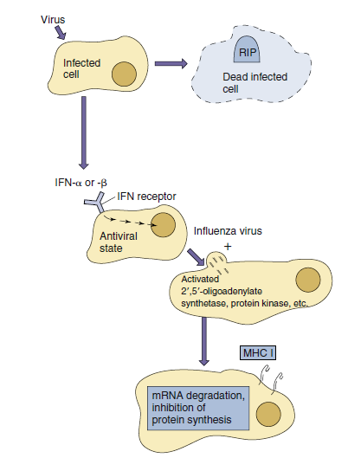

Time course of antiviral immune responses. CTL, Cytotoxic T lympho cyte; IFN, interferon. (Modified from Abbas, A.K., Lichtman, A.H., Pillai, S., et al., 2015. Cellular and Molecular Immunology, eighth ed. Elsevier, Philadelphia, PA.)
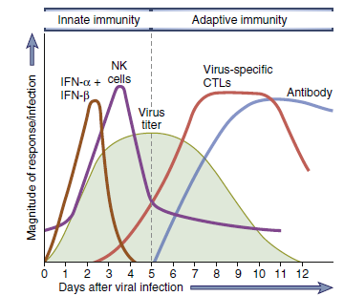

Examples of Viral Evasion of Immune Responses
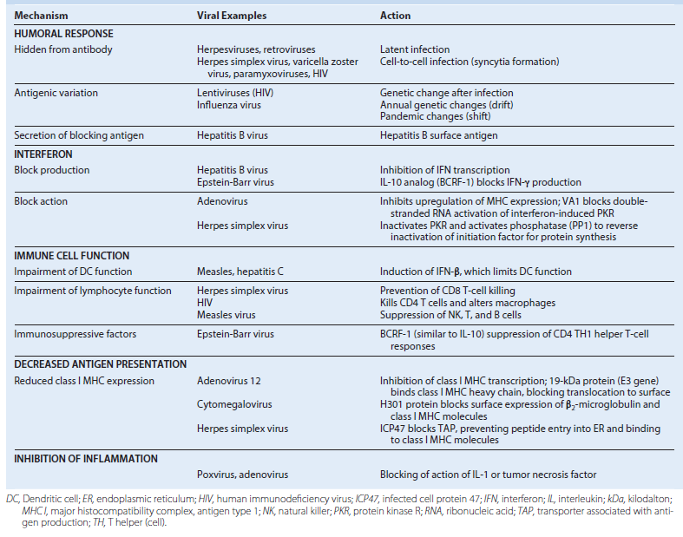

Summary of Antiparasitic Responses
Different immune responses are necessary depending on the nature of the parasite and the replicative stage.
Many parasites have multiple tricks to evade immune responses.
TH2 responses, through IgG and IgA, are important for preventing parasite binding to tissue, to block binding and entry into cells, to activate complement, and as an opsonin.
IgE bound to mast cells and eosinophils binds parasite and parasite antigen, and releases histamine and toxic substances to promote expulsion.
TH2 responses activate mucus secretion into colon to promote expulsion.
TH1 responses are especially important for intracellular infections (Leishmania) but promote inflammation.
Granuloma formation is important for intracellular infections (Schistosoma).
TH17 responses reinforce epithelial and neutrophil action for extracellular parasites.
Ig, Immunoglobulin; TH, T helper (cell).

Examples of Antiparasitic Immune Responses
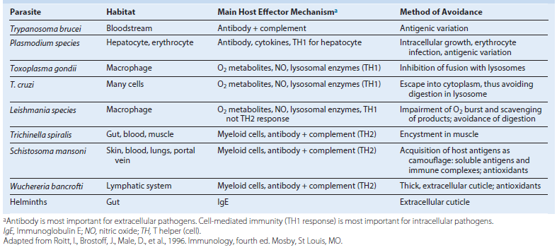

Elimination of nematodes from the gut. TH2 responses are important for stimulating the production of antibody. Antibody can damage the worm. Antigen binding to immunoglobulin E (IgE) bound to mast cells triggers release of histamine and toxic substances. Increased mucus secretion also promotes expulsion. IL, Interleukin; TH, T helper (cell); TNF, tumor necrosis factor. (From Roitt, I., Brostoff, J., Male, D., et al., 1996. Immunology, fourth ed. Mosby, St Louis, MO.)
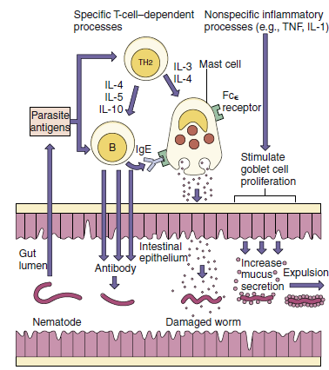

Hypersensitivity Reactions
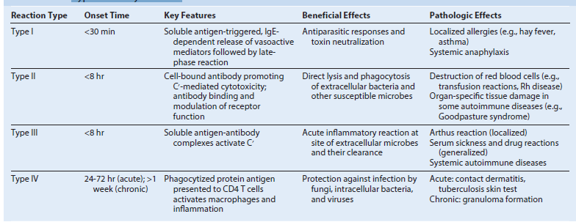

Type I hypersensitivity: immunoglobulin E (IgE)–mediated atopic and anaphylactic reactions. IgE produced in response to the initial challenge binds to Fc receptors on mast cells and basophils. Allergen binding and cross-linking of the cell-surface IgE promotes release of histamine and prostaglandins from granules to produce symptoms. Examples are hay fever, asthma, penicillin allergy, and reaction to bee stings. IL, Interleukin; TH, T helper (cell).

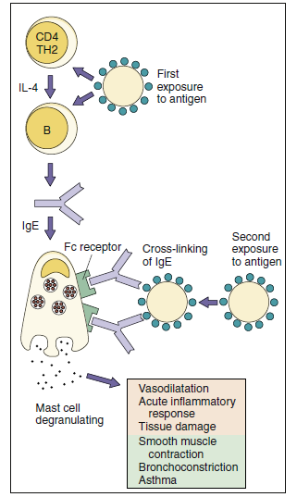

Type II hypersensitivity: mediated by cell-bound antibody and complement. Complement activation promotes direct cell damage through the complement cascade and by the activation of effector cells. Examples are Goodpasture syndrome, the response to Rh factor in newborns, and autoimmune endocrinopathies. ADCC, Antibody dependent cellular cytotoxicity; Ig, immunoglobulin.
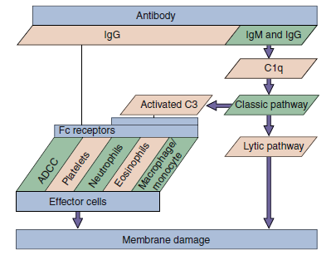

Type III hypersensitivity: immune complex mediated. Immune complexes can be trapped in the kidney and elsewhere in the body and can activate complement to promote inflammation. Examples are serum sickness, nephritis associated with chronic hepatitis B infection, and Arthus reaction.
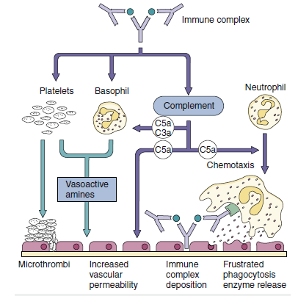

Type IV hypersensitivity: delayed-type hypersensitivity (DTH) mediated by CD4 T cells (TH1). In this case, chemically modified self-proteins are processed, and peptides are presented on antigen-presenting cells (APCs) to CD4 memory T cells cycling through the skin, which become activated and release cytokines (including interferon-_ [IFN-_]) that promote inflammation. Other examples of DTH are the tuberculin response (purified protein derivative test) and reaction to metals such as nickel. TCR, T-cell receptor; TH, T helper (cell).
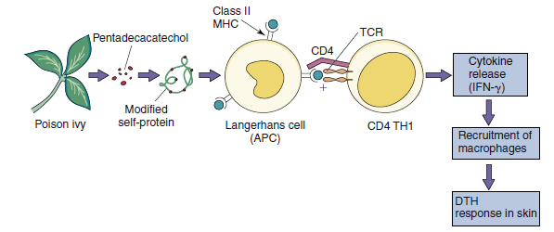

Important Characteristics of Four Types of Delayed-Type Hypersensitivity Reactions
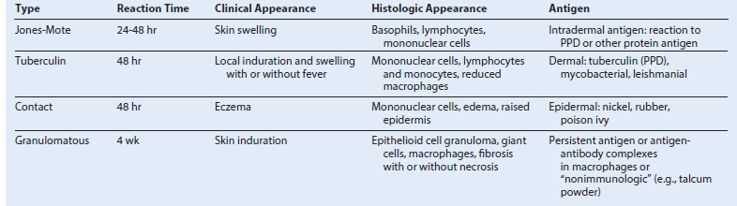

Contact and tuberculin hypersensitivity responses. These type IV responses are cell mediated but differ in the site of cell infiltration and in the symptoms. Contact hypersensitivity occurs in the epidermis and leads to the formation of blisters; tuberculin-type hypersensitivity occurs in the dermis and is characterized by swelling.
